**ASSESSMENT-2**

**DESIGN SPECIFICATION**

**NAME: MOHAMMED ZHOEB**

**SUBJECT: SYSTME ANALYSIS AND DESIGN (MIS605)**

**STUDENT ID: 00287693T**

**LECTURER: NAZRUL PRAMANIK**

**TABLE OF CONTENT**

1. **Context diagram 3**
2. **Data flow diagram (level-0) 4**
3. **level - 1 data flow diagram 5**
4. **Entity relationship diagram of online enrollment system of abc university 7**
5. **Database 8**
6. **Erd to physical relational database design 9**
7. **Conclusion 12**
8. **References 13**
9. **CONTEXT DIAGRAM:**

Context diagram is a valuable content of the modeling and act as an important tool of data representation. It allows an individual to design a model of higher level of a planned system having its own elements and its interactions within the environment of the system interest.

It consists of the system at the center with the external elements interacting with the system. The process flow within the system is not been depicted in the context diagram (Burge, 2011).

**Key benefits of context diagram:**

System boundaries and scope can be viewed much easily along with the other systems that are interfering with it

No additional skills or knowledge is required to view or understand the diagram

It can be drawn with much ease

It will be useful to all the stakeholders include in the project like data analyst, business analyst etc.

It can be expanded easily by the addition of different levels of Data flow diagram ("What is a Context Diagram and what are the benefits of creating one?", 2020).

**CONTEXT DIAGRAM FOR ONLINE ENROLLMENT SYSTEM AT ABC UNIVERSITY**

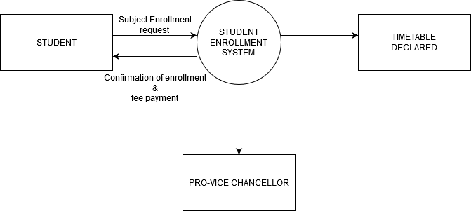

The above context diagram depicts about the process of student enrollment system which is the highest level of system within the environment, followed by the student which act as an external entity which is present in the rectangle box within the context diagram. The external entity usually triggers the action of the system.

Timetable declared and Pro-vice chancellor acts as an external entity within the context diagram. As this online enrollment system is envisaged by the Pro vice chancellor who has a complete look on the entire system.

The data flow is represented as an arrow pointed towards the main system with subject enrollment request and fee payment request as the flow towards the system and confirmation of enrollment and fee payment flow towards the entity from the system.

1. **DATA FLOW DIAGRAM.**

**LEVEL-0 DATA FLOW DIAGRAM:**

It depicts all the process that is present within the system. It shows the movement of information from one process to the other process within the system. In the level-0 data flow diagram the addition of the data store is been represented within the diagram (Franchitti, n.d.).

**Key Benefits of DFDs:**

It provide a detail brief about the system boundaries

The present system knowledge can be shared easily to the users

System components can be easily represented by the DFD technique

Technical as well as non-technical audiences can understand DFD with much ease

Every logic behind the system data flow is been supported by the DFD ("Advantages Vs Disadvantages of DFD’s…", n.d.).

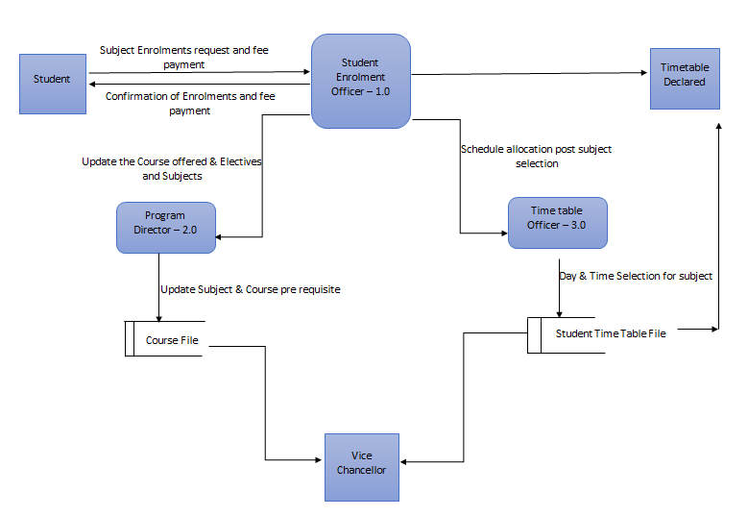The above context diagram usually represents the student enrollment officer as a main process which is the decomposition of the student enrollment system. Student, time table declared and Pro-Vice chancellor act as a source within the DFD. The Level-0 DFD consist of various processes like Program director, Time table officer. The flow of data occurs towards the Program director as the student enrollment officer updates the courses offered as well as core and elective subjects.

The program director process the information gained from the student enrollment officer and transfers the data flow of update pre requisites of subject and course. The data is stored in the database called as course file, which is viewed by the Pro-Vice Chancellor.

The student enrollment officer schedules the allocations of post subject selection to the timetabling officer who creates the time tables. The flow of data is done from the time tabling officer to the data base called as student timetable in the form of allocating day and time selection for subject. The database (subject timetable) can be viewed by the Pro-Vice Chancellor as well.

1. **LEVEL - 1 DATA FLOW DIAGRAM:**

In this data flow diagram an every process is been represented from the major process of level- 0 Data flow diagram. The movement of information from one process to another is been depicted within the diagram. Detail depiction of higher level process is done in this diagram (Franchitti, n.d.).

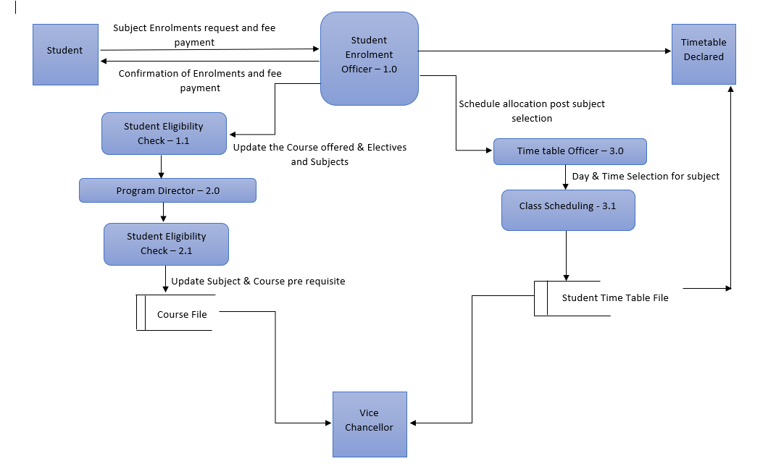

The above context diagram depicts the decomposition of the level- 0 Data flow diagram. The three major processes like student enrollment officer (1.0), program director (2.0), and time table officer (3.0) is been decomposed to a detail level as per the pre requisite of the level-1 DFD. The major process Student enrollment officer (1.0) consist of the sub process called as student eligibility check (1.1) where the students are been checked according to the study load on selecting of the subjects which is been approved by the student enrollment officer.

The process program director is been decomposed into the sub process as a subject pre requisite check (2.1). The program director checks the subject pre requisites with the student credentials before availing the course or subject to the student. The data is been stored in the course file data base, which is been viewed by the Pro-Vice Chancellor.

The process Time table officer (3.0) who creates the timetable is been decomposed into class scheduling (3.1) in which the classes are been scheduled based on the class offered within the campus and also to avoid the clashes with the other subjects. The data is been store in the student time table which is been transferred to the source called time table declared and it can also be viewed by the Pro-Vice Chancellor.

1. **ENTITY RELATIONSHIP DIAGRAM OF ONLINE ENROLLEMENT SYSTEM OF ABC UNIVERSITY**

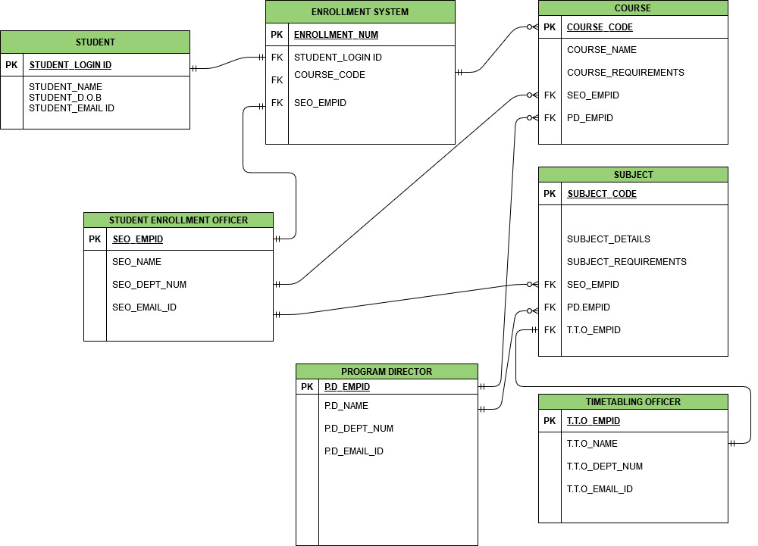

The above ERD diagram represents the online enrollment system of the ABC University. The ERD consist of main entities like student, enrollment system, courses, subject, student enrollment officer, program director, timetabling officer.

**STUDENT:**

The student entity consists of STUDENT_LOGIN_ID as a primary key, whereas the STUDENT_NAME, STUDENT_D.O.B, STUDENT_EMAIL act as attributes. The entity student shows one and only one relationship to the entity student enrollment system as one student is related to enrollment system.

**ENROLLMENT SYSTEM:**

The entity enrollment system consist of ENROLL_NUM as a primary key, whereas the STUDENT_LOGINID, COURSE_CODE, SEO_EMPID act as a foreign key. The enrollment system consists of a relationship of one to much relationship to the entity course.

**COURSE:**

The entity course consists of COURSE_CODE as a primary key, whereas COURSE_NAME and COURSE_REQUIREMENTS as a normal attributes. The SEO_EMPID, PD_EMPID as a foreign key.

**SUBJECT:**

The subject entity consists of SUBJECT_CODE as a primary key, whereas SUBJECT_DETAILS and SUBJECT_REQUIREMENTS as normal attributes. The entity consists of SEO_EMPID, PD_EMPID, and T.T.O_EMPID as a foreign key.

**STUDENT ENROLLMENT OFFICER:**

The entity STUDENT ENROLLMENT OFFICER consists of SEO_EMPID as a primary key, whereas SEO_NAME, SEO_DEPT_NUM, SEO_EMAIL_ID as normal attributes in the entity. The student enrollment officer has one to many relationship with the entity course and subject as only one officer is been involved in handling with the multiple courses as well as the subjects.

**PROGRAM DIRECTOR:**

The entity program director consists of PD_EMPID as a primary key whereas PD_NAME, PD_DEPT_NUM, PD_EMAIL_ID as normal attributes of the entity. The program director has one to many relationship with the entity course and subject as only one officer is been involved in handling with the multiple courses as well as the subjects.

**TIMETABLING OFFICER:**

The entity timetabling officer consists of T.O_EMPID as a primary key whereas T.O_NAME, T.O_DEPT_NUM, T.O_EMAIL_ID as a normal attributes of the entity. The entity timetabling officer has a relation of one to one relation as one officer is only responsible for making the changes or updating the time table to entity subjects.

**5. DATABASE:**

Database is a collection of data or information which is present in a structured form stored in a computer electronically. Database management system controls the database. DBMS along with the database is called as database system. Sql is the most common language used for the writing the data ("What is a database?", 2020).

**FILE SYSTEM:**

A file system is a place within the computer storage in which the files are named accordingly and stored logically. The individual files would be difficult to get retrieved without the file sytem ("What is a File System?", n.d.).

The data should be stored in the database of the system rather than file system, as database system show more advantages over the file system.

**Advantages of database system:**

Flexibility: database system is found to be more flexible in comparison to the file system

Data recovery: The data can be easily recovered as the system stores the backup of the entire data which can be done in case of failures.

Ease of data access: The data in database system is managed in such a way making ease of access to the user.

Security of data: There is a provision of giving access to the user to the authorized data thus providing the security to the data.

Less redundancy of data: normalization provides the less redundancy so no duplication of the data is observed.

Integrity of data: Due to normalization the data is less redundant providing more integrity to the data ("Advantages of DBMS over file system", n.d.).

**6. ERD TO PHYSICAL RELATIONAL DATABASE DESIGN:**



**PHYSICAL RELATIONSHIP DATABASE:**

**STUDENT**

|  |  |  |  |
| --- | --- | --- | --- |
| **STUDENT_LOGINID** | **STUDENT_NAME** | **STUDENT_D.O.B** | **STUDENT_EMAIL** |
| **1001** | **JOHN CARTER** | **9/10/1996** | [**CARTERJ@OUTLOOK.COM**](mailto:CARTERJ@OUTLOOK.COM) |
| **1002** | **ELTON CARY** | **10/11/1995** | [**CARYELTON@GMAIL.COM**](mailto:CARYELTON@GMAIL.COM) |
| **1003** | **MARRY ELITEQ** | **4/4/1996** | [**MARRYE@YAHOO.COM**](mailto:MARRYE@YAHOO.COM) |

The entity student consists of many attributes like STUDENT_LOGINID, STUDENT_NAME, STUDENT_D.O.B, and STUDENT_EMAIL. The attribute STUDENT_LOGINID act as a primary key for the student entity.

**ENROLLMENT SYSTEM**

|  |  |  |  |
| --- | --- | --- | --- |
| **ENROLLMENT_NUM** | **STUDENT_LOGINID** | **COURSE_CODE** | **SEO_EMPID** |
| **2001** | **1001** | **3001** | **1105** |
| **2002** | **1002** | **3001** | **1105** |
| **2003** | **1003** | **3001** | **1105** |

The entity enrollment system consists of ENROLLMENT_NUM, STUDENT_LOGINID, COURSE_CODE, and SEO_EMPID as the attributes. The ENROLLMENT_NUM act as a primary key whereas the other attributes act as a foreign key which serves as a primary key for the other entities.

**COURSE:**

|  |  |  |  |  |
| --- | --- | --- | --- | --- |
| **COURSE_CODE** | **COURSE_NAME** | **COURSE_REQUIREMENT** | **SEO_EMPID** | **PD_EMPID** |
| **3001** | **INFORMATION SYSTEM** | **COMPLETE ALL THE CORE** | **1105** | **1110** |
| **3002** | **MBA** | **COMPLETE DEGREE OF MANAGEMENT IN BACHELORS** | **1105** | **1110** |
| **3003** | **HEALTH SCIENCES** | **COMPLETE BACHLOR DEGREE OF HEALTH SCIENCES** | **1105** | **1110** |

The entity course consists of attributes like COURSE_CODE, COURSE_NAME, COURSE_REQUIREMENT, SEO_EMPID, and PD_EMPID as attributes in which COURSE_NAME act as a primary key. SEO_EMPID and PD_EMPID act as a foreign key.

**SUBJECT:**

|  |  |  |  |  |  |
| --- | --- | --- | --- | --- | --- |
| **SUBJECT_CODE** | **SUBJECT_DETAILS** | **SUBJECT_REQURIEMENTS** | **SEO_EMPID** | **PD_EMPID** | **T.O_EMPID** |
| **5001** | **12 HRS STUDY HOUR** | **COMPLETE 10 CREDIT** | **1105** | **1110** | **1205** |
| **5002** | **16 HR STUDY HOUR** | **COMPLETE PROFESSIONAL PRACTISE** | **1105** | **1110** | **1205** |
| **5003** | **8 HR STUDY HOUR** | **COMPLETE ALL THE CORE SUBJECTS** |  |  |  |

The entity subject consists of SUBJECT_CODE, SUBJECT_DETAILS, SUBJECT_REQUIREMENT, SEO_EMPID, PD_EMPID, and T.O_EMPID as the attributes. SUBJECT_CODE act as a primary key whereas SEO_EMPID, PD_EMPID, T.O_EMPID act as a foreign key.

**STUDENT ENROLLMENT OFFICER:**

|  |  |  |  |
| --- | --- | --- | --- |
| **SEO_EMP ID** | **SEO_NAME** | **SEO_DEPTNO** | **SEO_EMAILID** |
| **1105** | **DAVID JONES** | **0007** | **JONESD88@GMAIL.COM** |

The entity student enrollment officer consists of SEO_EMPID as a primary key whereas SEO_NAME, SEO_DEPTNO, SEO_EMAILID act as attributes.

**PROGRAM DIRECTOR:**

|  |  |  |  |
| --- | --- | --- | --- |
| **PD_EMPID** | **PD_NAME** | **PD_DEPTNUM** | **PD_EMAILID** |
| **1110** | **TONY ROBERT** | **0552** | **RTONY@GMAIL.COM** |

The entity program director consist of PD_EMPID, PD_NAME, PD_DEPTNUM, PD_EMAILID as general attributes in which PD_EMPID act as primary key.

**TIMETABLING OFFICER:**

|  |  |  |  |
| --- | --- | --- | --- |
| **T.O_EMPID** | **T.O_NAME** | **T.O_DEPTNUM** | **T.O_EMAIL.ID** |
| **1205** | **JIM TIMBER** | **0555** | **TIMBERJ99@GMAIL.COM** |

The entity timetabling officer consist of T.O_EMPID, T.O_NAME,T.O_DEPTNUM, T.O_EMAIL.ID as general attributes in which T.O_EMPID act as primary key.

**NORMALIZATION TO 3NF:**

**Normalization:**

The complex data can be converted into the simple structure which is more stable is called as normalization.

Mostly two rules are commonly followed:

2NF: whole key identifies the non-primary key attributes.

3NF: No dependencies are been identified between the non-primary key attributes (Valacich, 2015).

The above mentioned ERD diagram the tables segregation is done based on the normalization rules for example

**Enrollment system:**

|  |  |  |  |
| --- | --- | --- | --- |
| ENROL_NUM | STUDENT_LOGINID | COURSE_CODE | SEO_EMPID |
| **2001** | **1001** | **3001** | **1105** |
| **2002** | **1002** | **3001** | **1105** |
| **2003** | **1003** | **3001** | **1105** |

The above table consists of STUDENT_LOGINID, COURSE_CODE, and SEO_EMPID the details can be fetched in the respective tables such as course table, student table, student enrollment officer table respectively.

The above mentioned table consists of unique single value for each record – 1NF

Along with being in 1NF it also complies by the primary key (ENROL_NUM) which constitutes 2NF.

Along with being in 2NF the above mentioned table does not have any transitive functional dependencies, which makes it 3NF.

**CONCLUSION:**

The above report describes about the online enrollment system of the ABC University along with the requirements of data modeling. It describes about the context diagram and its components involved. The report also illustrates about the level-0 data flow diagram which is the decomposition of the context diagram. Followed by the level-1 DFD is also represented in the report. All the entities were been identified and it was represented graphically using the Entity Relationship Diagram. Each entities were been described much briefly in the report. The report has also given a brief about the advantages of storing the data into the database rather than storing in the file system. The given ERD was been translated into the relational database making the data easy to understand. Normalization of the data was done to 3NF according to the rules of data normalization.

**REFERENCES:**

Burge, S. (2011). The Systems EngineeringTool Box. Retrieved from <http://www.burgehugheswalsh.co.uk/Uploaded/1/Documents/CD-Tool-Box-V1.0.pdf>

What is a Context Diagram and what are the benefits of creating one?. (2020). Retrieved 28 July 2020, from <https://www.modernanalyst.com/Careers/InterviewQuestions/tabid/128/ID/1433/What-is-a-Context-Diagram-and-what-are-the-benefits-of-creating-one.aspx>

Franchitti, D. Session 5 - Main ThemeSoftware Analysis and Design. Retrieved from <http://www.nyu.edu/classes/jcf/g22.2440-001_sp06/slides/session5/g22_2440_001_c51.pdf>

Advantages Vs Disadvantages of DFD’s…. Retrieved 29 July 2020, from <https://eternalsunshineoftheismind.wordpress.com/2013/02/20/advantages-vs-disadvantages-of-dfds/>

What is a database?. (2020). Retrieved 30 July 2020, from <https://www.oracle.com/au/database/what-is-database.html>

What is a File System?. Retrieved 30 July 2020, from <https://searchstorage.techtarget.com/definition/file-system>

Advantages of DBMS over file system. Retrieved 30 July 2020, from <https://beginnersbook.com/2015/04/dbms-vs-file-system/>

Valacich, J. (2015). *ESSENTIALS OF SYSTEM ANALYSIS AND DESIGN* (p. 315).